# Dream Tech

Setting up for first time use

Prerequisites.

* Internet Information Services Manager
* Microsoft SQL Server 2014 or later
* Visual Studio 2012 or later

**Setting up** For first time use

The first thing to be done will be setting up the database. A database template has been made available called dream_tech.bak. This template contains the tables, all the relationships and some default data for testing. Copy this file to your SQL server backup location as shows below. 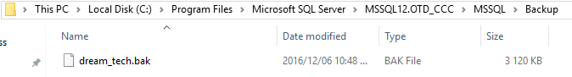

Now Open Microsoft SQL Server Management Studio. Right click on System Database and select Restore Database. 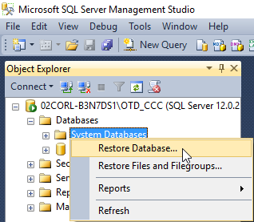

Under Source, select Device the click the option to select a location. The pop up will appear, now you can click add to find the location of the .bak file. 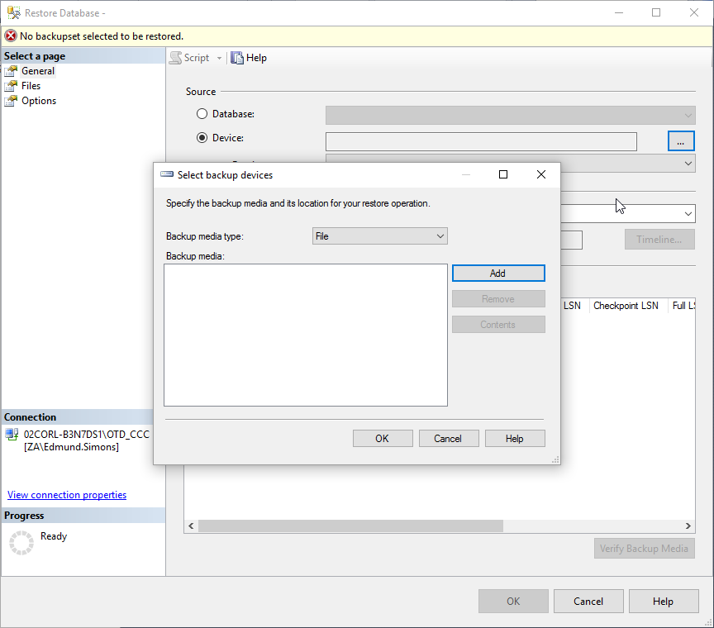

The application will automatically open the Backup location. Select the backup and click OK.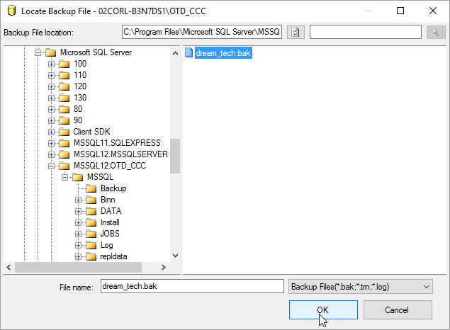

To restore the content of the .bak file, click OK. 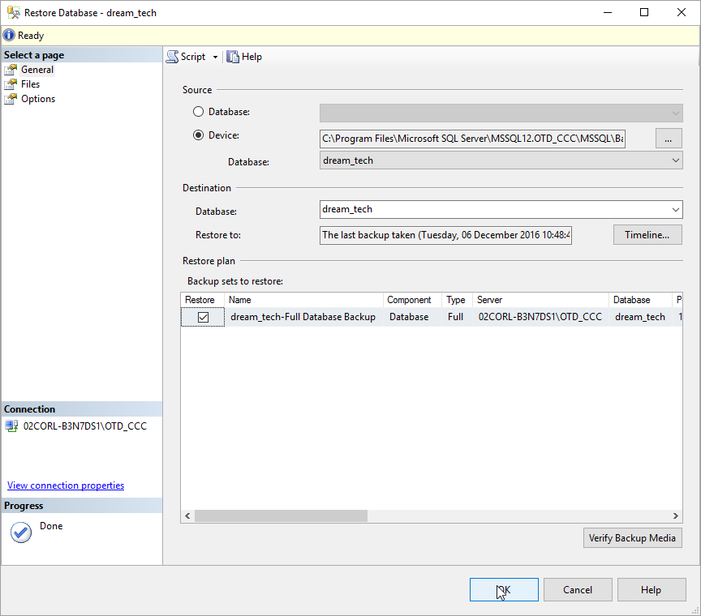

The database has now been restored. 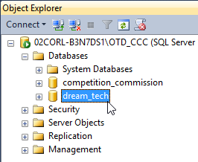

Now that the database has been restored, the application can be tested. Open the applicant in Visual Studio and build it. This is done from the Build tab, under the Build tab, select Build Solution as displayed in the image below. 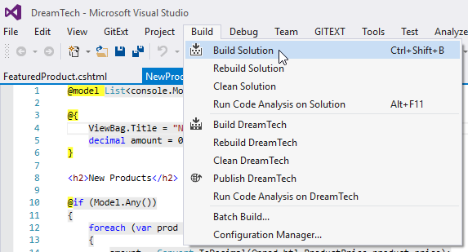

Once built, the application can now be Published. Under the Build tab, select Publish DreamTech. 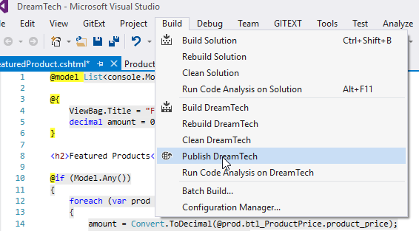

The publish window will now be displayed. Select Custom, as shown below.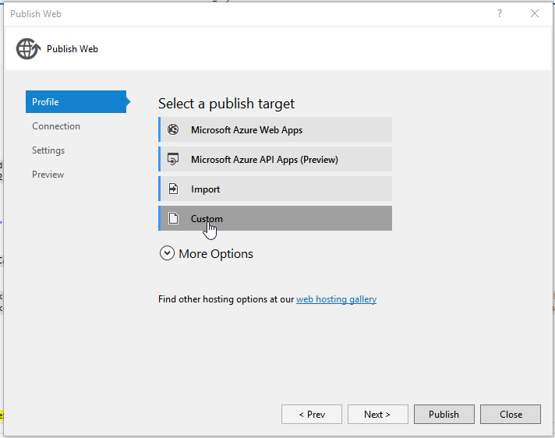

Name the export project DreamTech and click OK. 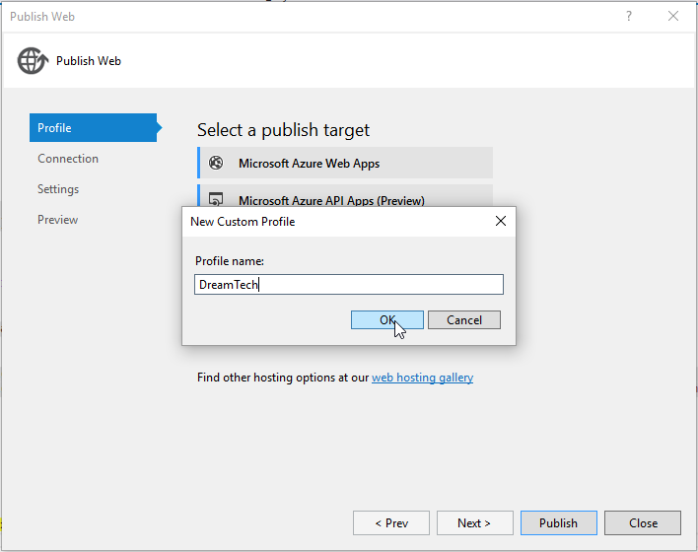

The Publish Method to be used is File System as shown below. 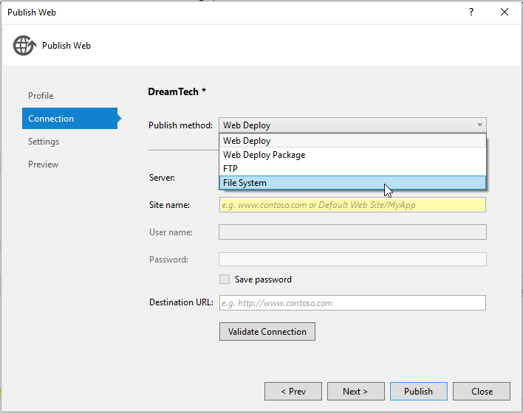

Set a Target location where the project can be sent to. 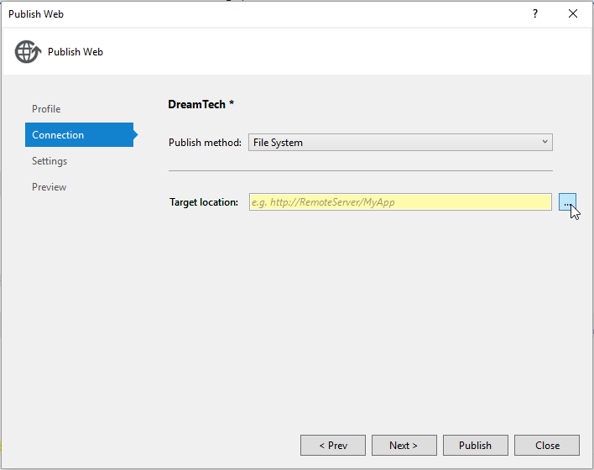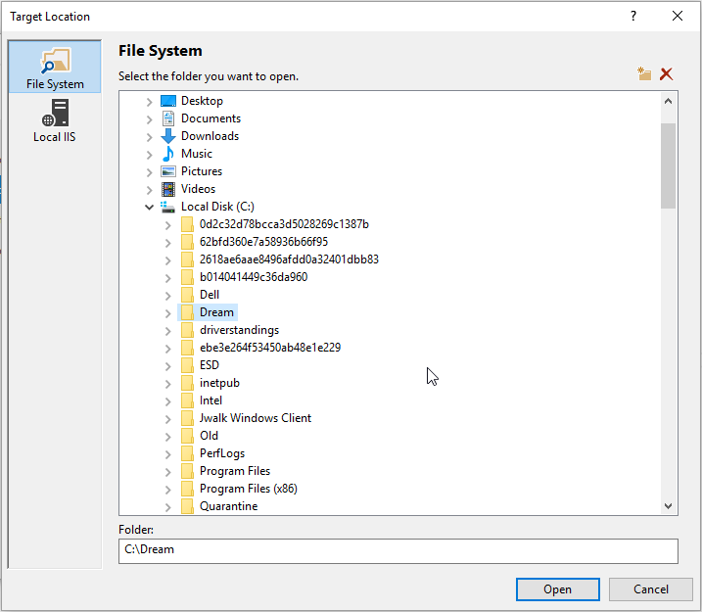

Once Selected, click Publish. 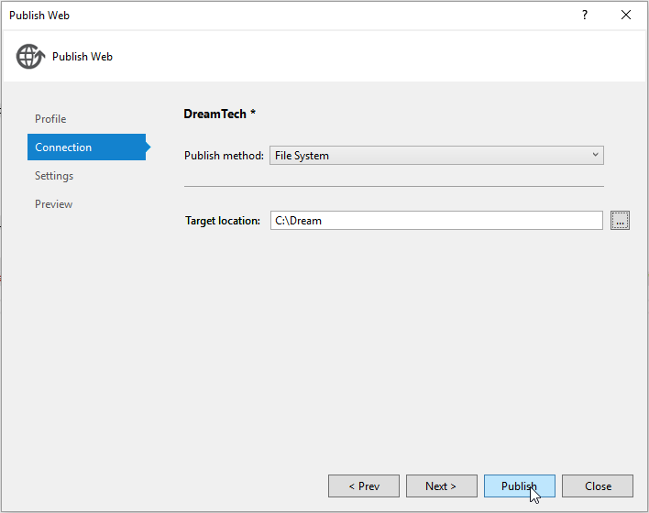

Open the start window and search for “iis”. Select Internet Information Services (IIS) Manager.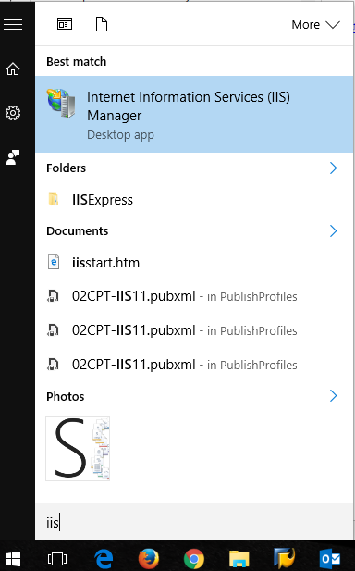

When open, right click on Sites and Select “Add Website...”. 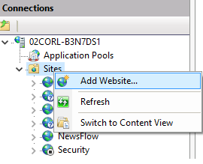

Complete the fields as follows, select the exported location of the application and click OK. Note, the port number is dependent on a port that is available on your machine. 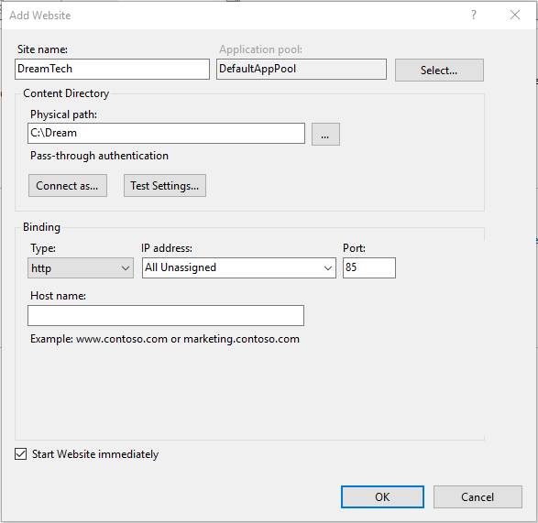

On the left, the application will now be displaying in the list. 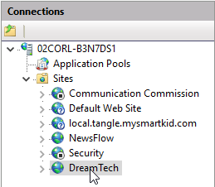

On the right, under Browse Website, select Browse *(Port number) (http). 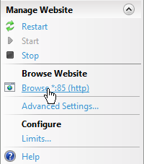

The application home screen will now display. 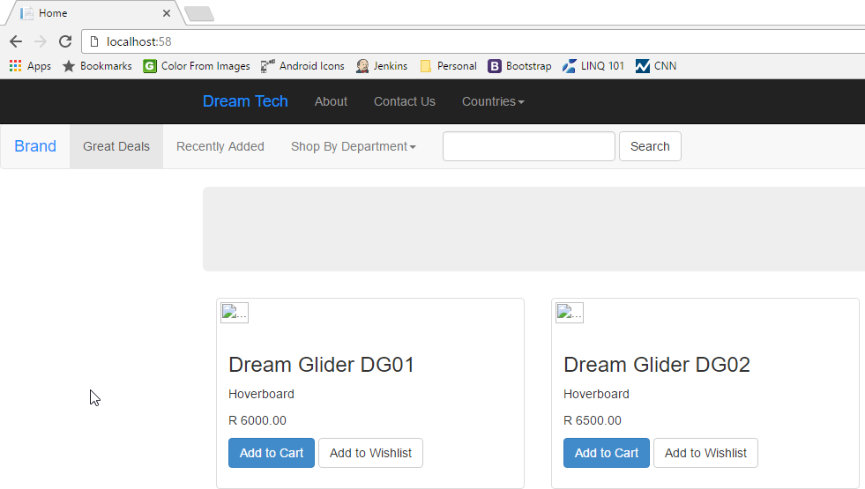

**Application status**

* The buying process is not complete. The order process will only be completed once the company decides on a third-party payment system. Negotiations are currently underway.
* Professional images of the products will soon be uploaded.